Name:  Teacher: | ____________________________________  ________________ |  | Date:_________
 | Year 9 Mathematics  SCORE:  / 45  Test 4  Topic – Trigonometry
Total Time: | 45 minutes
Weighting: | 6 %
Equipment: | To be provided by the student:  Pens and Pencils, scientific calculator, ruler and a A4 page of notes.

Multiple choice questions 6 marks

Question 1. What is the ratio for Sine?

- HYP/OPP
- OPP/ADJ
- OPP/HYP
- ADJ/OPP

Question 2. Which ratio would be the most suitable to determine the value of x?

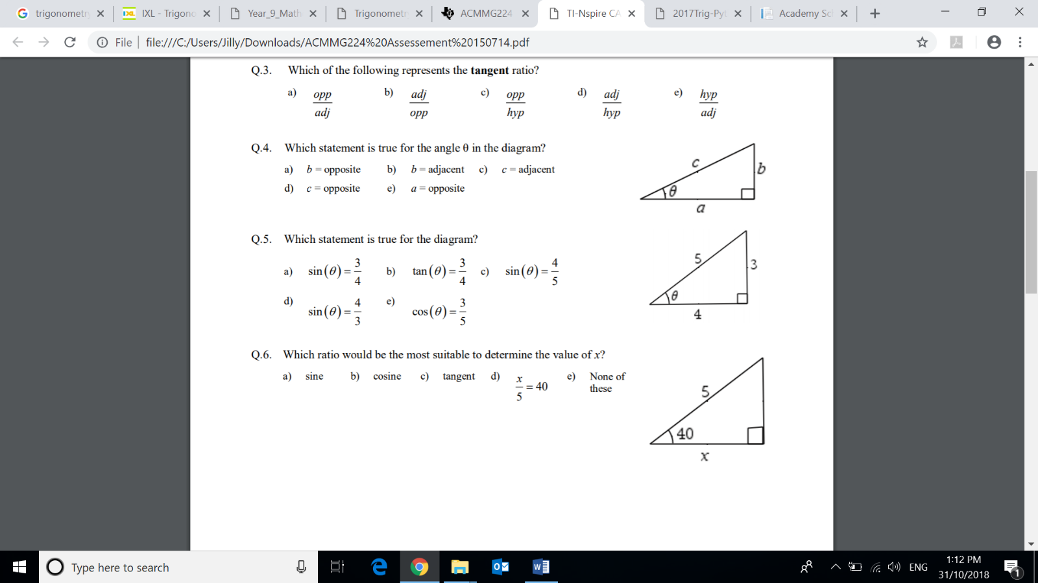
- sine
- cosine
- Tangent
- $\frac{x}{5}=40$

Question 3. Which statement is true for the diagram?

- $\sin{θ= \frac{3}{4}}$
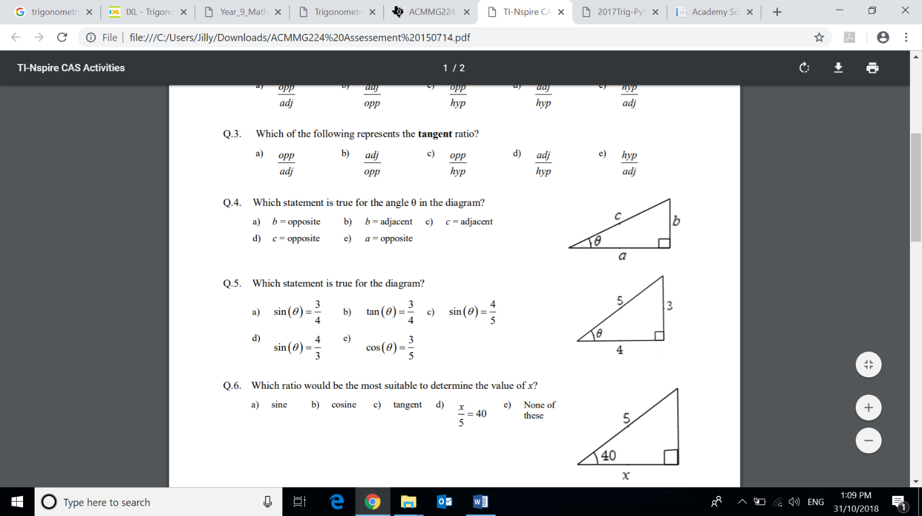
- $\tan{θ= \frac{3}{4}}$

- $\sin{θ= \frac{4}{5}}$

- $\sin{θ= \frac{4}{3}}$

Question 4. What is the correct ratio to find $\tan{θ}$

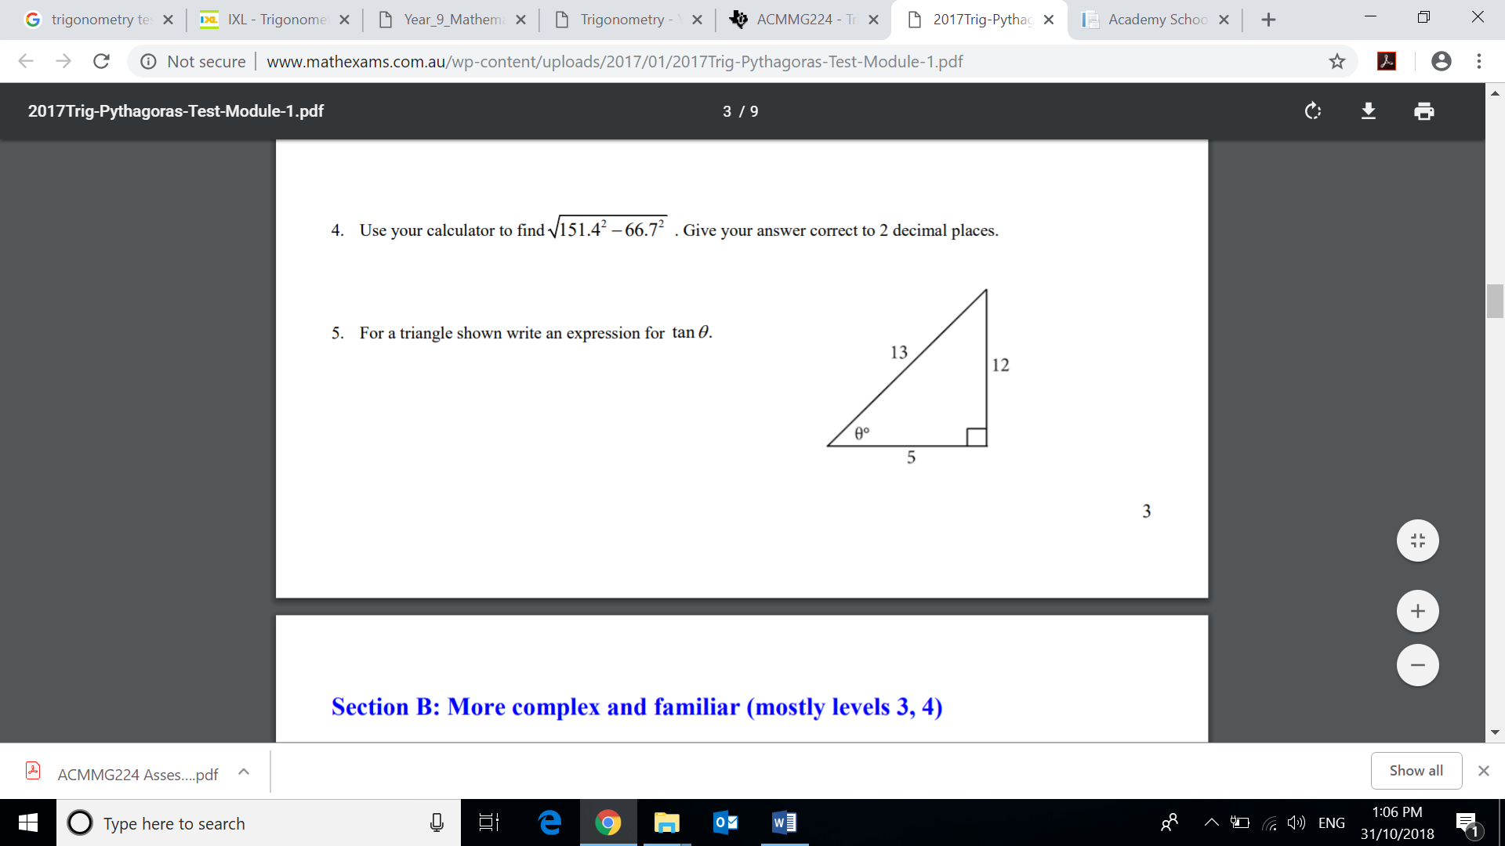
- 13/12
- 5/12
- 5/13
- 12/5

Question 5. Which statement is true for the angle θ in the diagram?


- b = opposite
- b = adjacent
- c = adjacent
- a = opposite

Question 6. What is the length of the adjacent side when considering the 20$°$ angle?

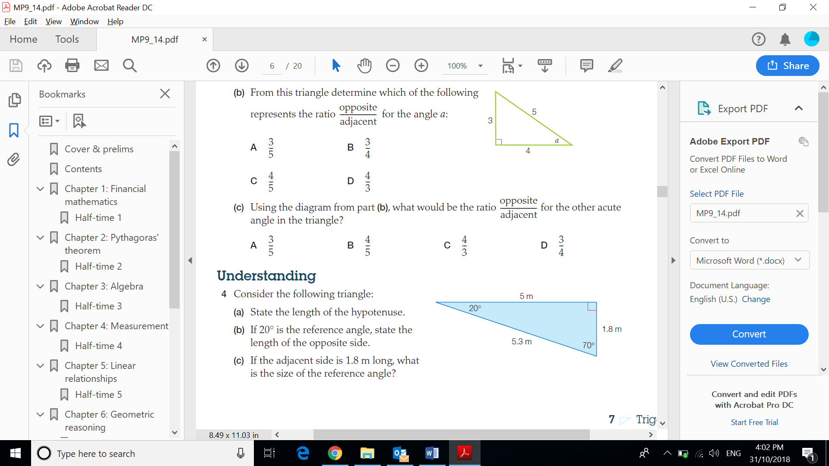
- 20
- 5
- 1.8
- 5.3

Short answer questions 39 marks
Show FULL working out to get FULL marks

Question 7. Complete the following using words from the list below. [4 marks]
adjacent angle of depression angle of elevation cosine
hypotenuse opposite sine tangent

The _______________________ ratio is found by dividing the opposite side by the hypotenuse.

The tangent ratio is found by dividing the _______________________ side by the _______________________ side.

When you look up at an aeroplane the angle between the horizontal and your line of sight is called the ___________________________.
Question 8. Calculate the lengths of the sides marked with letters in each of the following triangles, giving your answers to 3 decimal places. [6 marks]

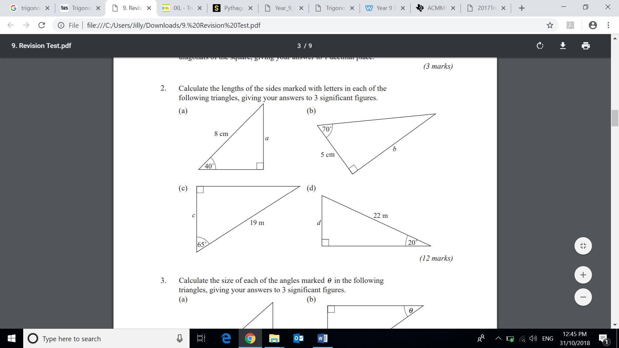



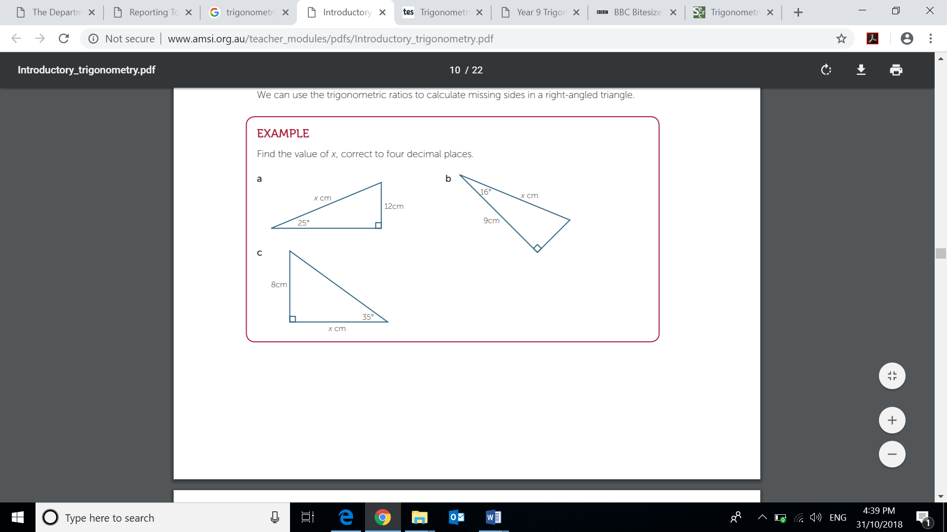

Question 9. Calculate the size of each of the angles marked θ in the following triangles, giving your answers to the nearest degree. [4 marks]

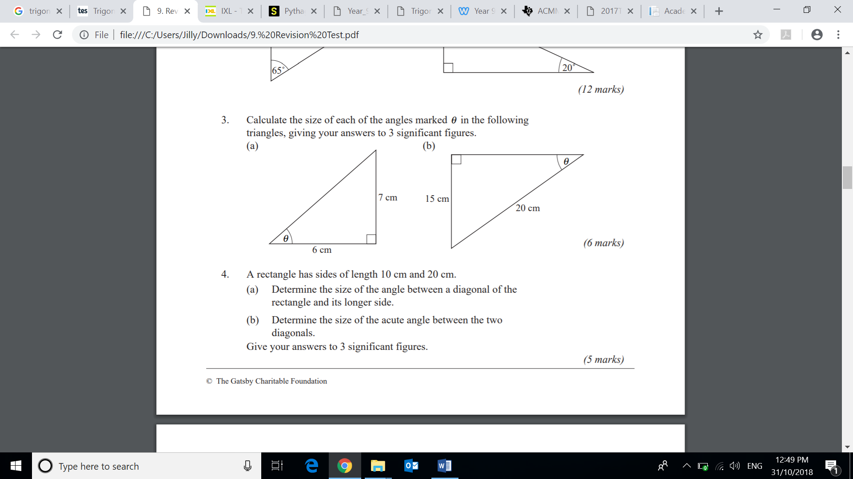



Question 10. For the triangle shown, calculate the length of CD and AD. Give your answers to 3 decimal places. [4 marks]

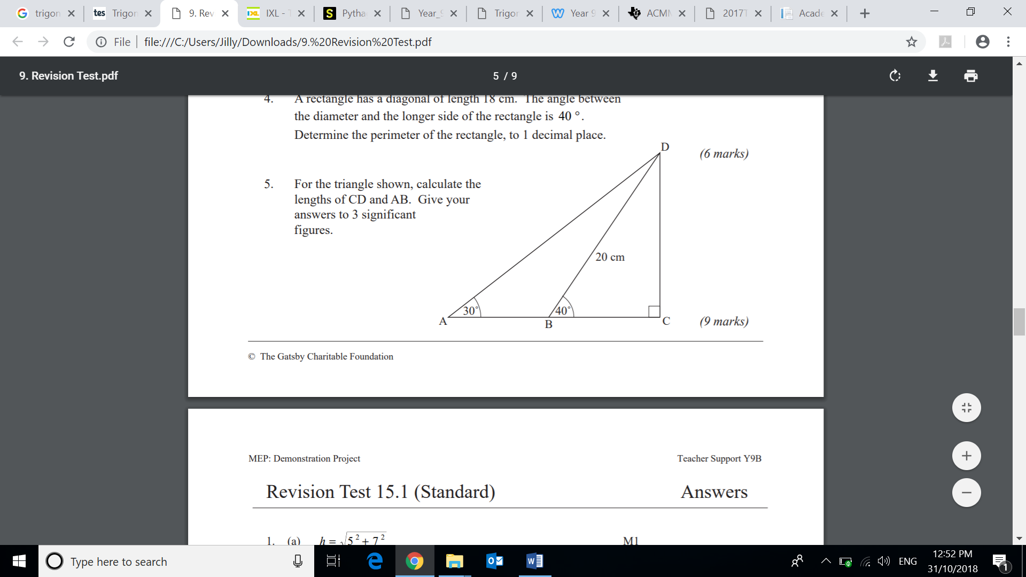

Question 11. A ladder of length 3 m makes an angle of 32° with the wall. [5 marks]

- Draw a diagram and label the given values.

- How far is the base of the ladder from the wall?

- What angle does the ladder make with the ground?

Question 12. From the top of a 25 m lighthouse, on a 314 m tall cliff, the angle of depression to a sailing boat out in the ocean is 40°. How far is the sailing boat from the base of the cliff to the nearest metre?
[4 marks]

Question 13. The following answers were given by a student on a trigonometry test. [6 marks]
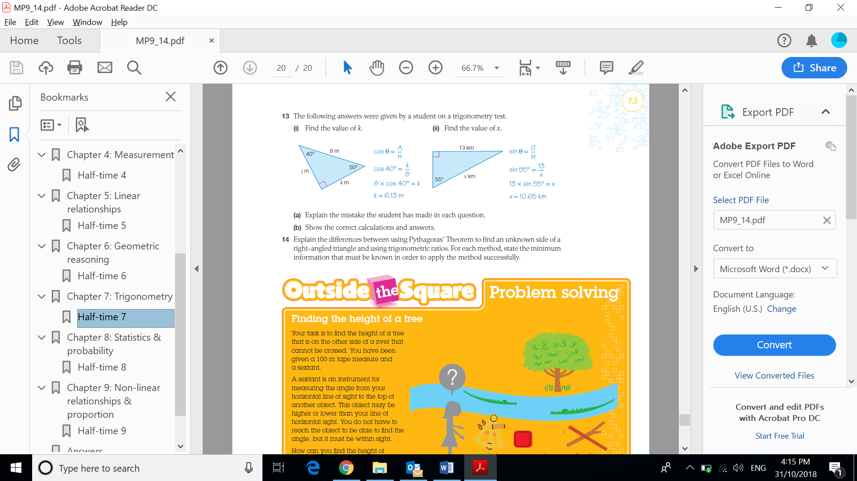

- Explain the mistake the student has made in each question

- Show the correct calculations and answers for each question.

Question 14. From an observer at O who is 200m from a building, the angles of elevation to the bottom and top of a flagpole are 36$°$ and 38$°$ respectively. Find the height of the flagpole to the nearest hundredth. [6 marks]

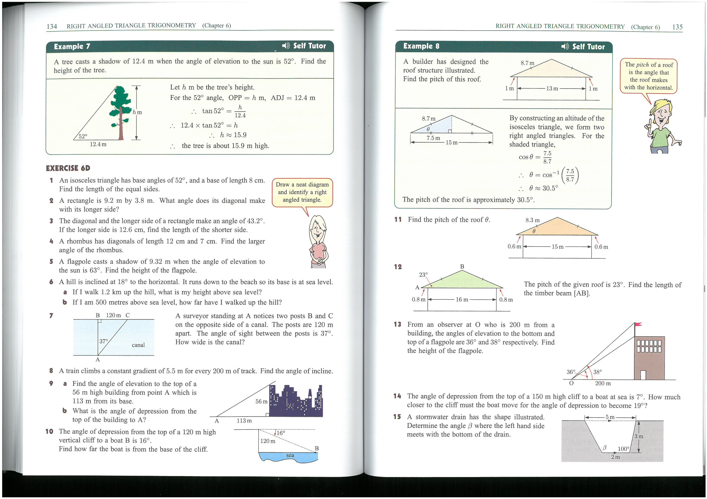

END OF TEST

